­



# SYNOPSIS

**G.H. RAISONI COLLEGE OF ENGINEERING AND MANAGEMENT**

(An Autonomous Institute under UGC Act 1956 & Affiliated to Savitribai Phule Pune University)

Department of Information Technology Academic Year 2023-24

**PROJECT TITLE:**

**“Stock Market Prediction Using Machine Learning”**

|  |  |
| --- | --- |
| **PROJECT GROUP NO: 15** | GUIDE NAME: **Ms. Vaishali Anaspure** |

|  |  |
| --- | --- |
| **ROLL NO** | **NAME OF STUDENT** |
| 04 | Aditya Munjal |
| 08 | Atharva Chavan |
| 10 | Fazal Mehmood |
| 12 | Ganesh Shinde |

|  |  |
| --- | --- |
| **PROJECT AREA** | **PROJECT PLATFORM** |
| Machine Learning, Stock Market, Financial Analysis, Time Series Forecasting. | ***Software: Jupyter notebook Technology:*** Python. |

**Under the Guidance of…**

**Ms. Vaishali Anaspure**

**In the partial fulfillment of the degree of Bachelor in Engineering**

# ABSTRACT

The stock market is a complex and dynamic system that attracts investors and traders seeking to make profitable decisions. Predicting stock prices accurately has always been a challenging task due to the involvement of various influencing factors and unpredictable market behavior. This project aims to employ machine learning techniques to develop a robust and efficient stock prediction model. By analyzing historical stock data and relevant market indicators, the model seeks to forecast future price movements, providing valuable insights for investors and financial analysts.

# KEYWORDS

Stock Prediction, Machine Learning, Stock Market, Financial Analysis, Time Series Forecasting.

# INTRODUCTION

The introduction of machine learning in stock prediction has opened up new avenues for analyzing market trends and making data-driven investment decisions. Traditional methods based on fundamental and technical analysis have limitations in handling vast amounts of historical data and detecting intricate patterns. By leveraging the power of machine learning algorithms, this project intends to overcome these limitations and create a predictive model capable of capturing intricate market dynamics.

# LITERATURE SURVEY

|  |  |  |  |
| --- | --- | --- | --- |
| **Srno** | **Published Year [References]** | **Research Paper Name** | **Description** |
| 1 | (2019)  [1] | Stock price Prediction using LSTM | This paper explores the use of LSTM network for stock prediction, show casting promising results. |

|  |  |  |  |  |  |
| --- | --- | --- | --- | --- | --- |
|  | 2 | (2020)  [2] | A Deep Reinforcent  Learning Framework for the Financial Portfolio Management Problem | The paper introduces a reinforcement learning approach to manage financial portfolios effectively. |  |
| 3 | (2021)  [3] | Machine Learning  for stock Market Prediction: An Overview | This paper provides a comprehensive overview of  various machine learning techniques used in stock prediction |
|  |  |  |  |  |  |
| 4 | (2019)  [4] | Stock Market Prediction using support Vector Machines | The Study investigate the application of support vector machines for stock market prediction. |
|  | | | | | |

**GOALS & OBJECTIVES**

The primary goal of this project is to develop an accurate and robust stock prediction model using machine learning techniques. The specific objectives include:

Collecting and preprocessing historical stock market data.

Evaluating different machine learning algorithms for time series forecasting. Developing a comparative analysis of the selected models based on their performance. Implementing an interactive interface for users to obtain stock predictions.

# SCOPE

The scope of this project encompasses various aspects of stock market prediction using machine learning. It involves the development of a reliable model that considers technical indicators, historical stock prices, and other relevant features to forecast future prices. However, it is important to note that the stock market is influenced by multiple unpredictable factors, and while the model aims for accuracy, it may not provide infallible predictions.

# MOTIVATION

The motivation behind this project lies in the desire to provide investors and financial analysts with a powerful tool that can assist in making informed decisions in the stock market. By leveraging machine learning algorithms, we aim to enhance prediction accuracy and offer valuable insights into potential stock price movements.

* To determine the data fluctuating or stable entities for the learning and implement for the real-world use of system.
* decipher real time changes
* characteristics of stock price, increasing interest in investments in stalks and awareness about means of studies for stalks.
* Analysis is given on the trend in given for period of time

# EXISTING SYSTEM

The existing system for stock prediction often relies on traditional methods like technical analysis, fundamental analysis, and expert opinions. While these approaches have been utilized for years, they may not be efficient in handling large-scale data and identifying complex patterns. Machine learning-based stock prediction models offer the advantage of data-driven analysis and adaptability to changing market conditions.

# ADVANTAGES

* Data-Driven Insights: Machine learning enables data-driven decision-making, reducing reliance on human intuition alone.
* Handling Complex Data: ML models can handle vast amounts of historical data and detect intricate patterns that human analysis might miss.
* Improved Accuracy: ML algorithms have the potential to provide more accurate stock price predictions compared to traditional methods.
* Real-Time Predictions: Once trained, the model can make predictions in real-time, allowing for timely investment decisions.

# DISADVANTAGES

Market Volatility: Sudden and unexpected market fluctuations can challenge the reliability of any prediction model.

Overfitting: ML models may over fit the training data, leading to poor generalization to new, unseen data.

Data Quality: The accuracy of predictions heavily relies on the quality and relevance of historical data.

**PROPOSED SYSTEM**

Stock is unpredicted and liberal in nature. The follow of the same is impressive and reluctant

in nature. Finding the predictability and getting the nearest is the best hit goal for the same.

The exact and accurate estimation of the same is never-less possible.

There are various constrains that in-fluctuate the pricing and the rate of stock.

Those constrains had to be taken in consideration before jumping to the conclusion

and report derivation.

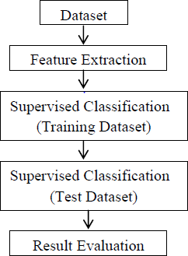

Here as described in the figure above, the proposed system will have an input from the dataset

which will be extracted featured wise and Classified underneath. The classification technique

used is supervised and the various techniques of machine level algorithms are implemented on

the same. Training Dataset are created for training the machine and the test cases are derived

and implemented to carry out the visualization and the plotting’s.

**SYSTEM ARCHITECTURE**

**FOR PROPOSED SYSTEM**

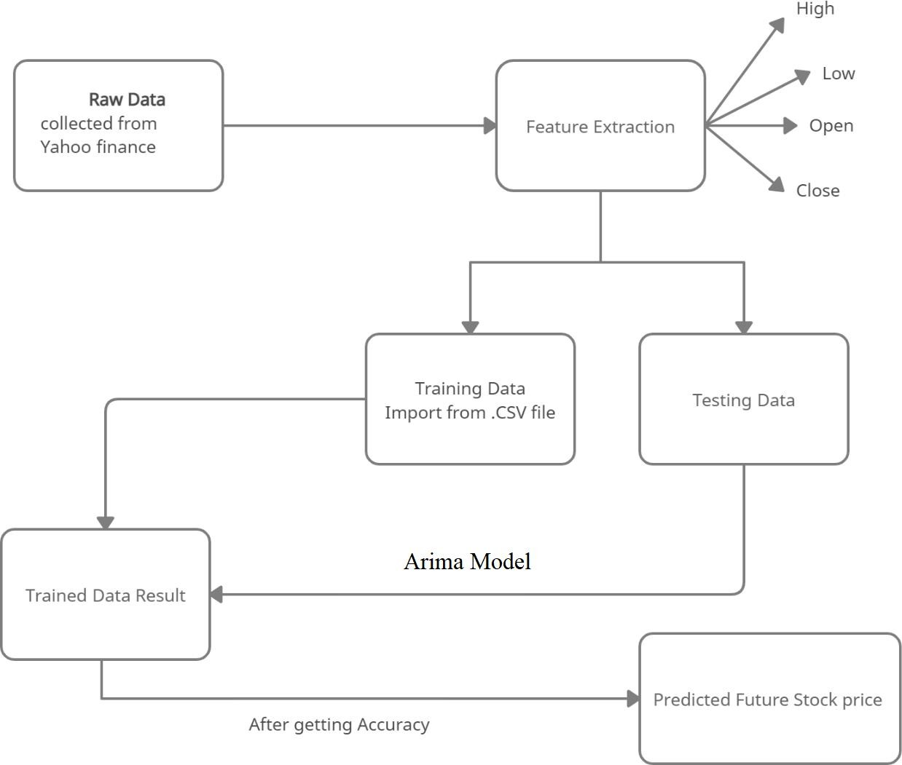

The dataset we use for the proposed project is been taken from BSE and NSE. But this data set is in raw format. The data set is a collection of valuation of stock market information about some companies. The initial step is to convert raw data into processed data. Which is done by feature extraction, since the raw data collected have multiple attributes but only some of those attributes are needed for the prediction. Feature extractionis a reduction process.

The structure, behavior and views of a system is given by structural model.

# Tools used:

**Hardware:**

Processor : Intel i3 or above

RAM : Minimum 225MB or more. Hard Disk: Minimum 2 GB of space Input Device : Keyboard

Output Device : Screens of Monitor or a Laptop

# Software:

Operating System: Windows and Linux

IDE: Visual Studio, Jupiter notebook , anaconda navigator Data Set: CSV File

Visualization library: Math plot lib, pandas

Server: Webserver with HTTP Process, Radis server

# CONCLUSION

This project endeavors to harness the potential of machine learning to build an effective stock prediction model. By analyzing historical data and employing various ML algorithms, we aim to develop a valuable tool for investors and analysts in making well-informed decisions.

However, stock market prediction is inherently uncertain, and the success of the model will be subject to the volatility and dynamics of the market itself. The outcomes of this project will provide insights into the feasibility and effectiveness of machine learning techniques in the domain of stock prediction.

# REFERENCES

1. Analyzing Stock Market Trend Prediction using Machine & Deep Learning Models 978-1-7281-9437-0/20/$31.00 ©2020 IEEE.DOI:10.1109/CITISIA50690.2020.9371852 Doan Yen Nhi Le1, Angelika Maag2, Suntharalingam Senthilananthan.
2. Stock Market Prediction using Ensemble of Deep Neural Networks. 978-1-7281- 6946-0/20/$31.00 ©2020 IEEE Lu Sin Chong, Kian Ming Lim, Chin Poo Lee.
3. Predicting Stock Market trends using machine learning and deep learning.DOI:10.1109/ACCESS.2020.2012966, IEEE Mojtaba Nabipour, Pooyan Nayyeri, Hamed Jabani.
4. Prediction of TCS Stock Prices Using Deep Learning Models. 978-1-6654-0521- 8/20/$31.00 ©2021 IEEE | DOI: 10.1109/ICACCS51430.2021.944185 Srilakshmi.K Sai Sruthi.Ch.
5. Predicting Stock Market Price: A Logical Strategy using Deep Learning|978-1-6654- 0338-2/21/$31.00 ©2021 IEEE| DOI:10.1109/ISCAIE51753.2021.943181 Milon Biswas, Milon Biswas, Md. Ashraful Islam.
6. [Analysis of Investor Sentiment and Stock Market Volatility Trend Based on Big Data](https://ieeexplore.ieee.org/document/8806504/) [Strategy](https://ieeexplore.ieee.org/document/8806504/) [2020 International Conference on Robots & Intelligent System](https://ieeexplore.ieee.org/xpl/conhome/8790374/proceeding) Year:2020 IEEE Du Peng.
7. [Sentiment Analysis for Stock Price Prediction](https://ieeexplore.ieee.org/document/9175549/) [IEEE Conference on Multimedia](https://ieeexplore.ieee.org/xpl/conhome/9166909/proceeding) [Information Processing and Retrieval](https://ieeexplore.ieee.org/xpl/conhome/9166909/proceeding) Year: 2020 | Conference Paper | Publisher: IEEE Rubi Gupta, Min Chen.
8. Analysis of machine learning algorithm for stock market prediction. 978-1-7281- 7213-2/20/$31.00 c 2020 IEEE Sahil vazirani, Abhishek sharma and Pavika sharma.